KNN Modelling for Online Purchase Prediction
  - MH6805 Machine Learning Group Project
This report explains the design, modelling workflow and final results of the KNN component for integration into the group report. The primary model excludes PageValues. A separately tuned model including this feature is reported as a sensitivity analysis.
The primary model identifies purchasing sessions, but with a substantial precision–recall trade-off. At the threshold selected using training data, test recall is 0.6911, precision is 0.2933 and F1 is 0.4119. Including PageValues yields stronger performance, although its availability at prediction time remains unresolved.

1 Task and data
Each observation represents a website session. Revenue is encoded as 1 for purchase and 0 for no purchase. The task predicts observed purchase outcomes rather than directly measuring subjective purchase intention. The fixed training and test partitions supplied by the group were preserved without resplitting or combining them.
Partition | Sessions | Purchases | Purchase rate
Training | 9,764 | 1,526 | 15.63%
Test | 2,441 | 382 | 15.65%

The supplied data contain 17 predictors. The primary model uses 16: nine numerical and seven categorical variables. Revenue is used only as the target. Training data support EDA, preprocessing comparisons, hyperparameter search and threshold selection. The test set is reserved for final performance evaluation after these choices are fixed, apart from earlier integrity checks.

Data checks and retention decisions
Checks found no missing values, duplicate rows within either partition, or identical complete records or predictor combinations shared across partitions. Numerical features contained no negative or infinite values, and the relevant range and type checks passed. No imputation, duplicate removal or row deletion was required. Zeros and large observations were retained because their magnitude alone does not establish an error.

2 How EDA informed preprocessing
EDA used training data only. Purchases account for 15.63% of sessions, so predicting no purchase for every session achieves 84.37% training accuracy while purchase recall is zero. This motivates AP as the primary tuning metric, with precision, recall, F1 and ROC-AUC reported alongside accuracy.
Page counts and durations are strongly right-skewed and differ considerably in scale. For example, ProductRelated_Duration has mean 1209.732 and median 613.945. The median product-page count is 29 for purchase sessions and 16 for non-purchase sessions, but the distributions overlap. Purchase rates also vary across categorical groups; extreme rates in small groups should not be treated as stable findings.
Page counts and their corresponding durations are strongly correlated: Spearman correlations are 0.952 for Informational, 0.940 for Administrative and 0.877 for ProductRelated. These pairs may contribute overlapping information to distance calculations. Features were not removed solely on this basis; no dimensionality-reduction or reduced-feature experiment was performed.

Feature treatment
Feature group | Treatment
Six page-count and duration variables | Compare standardization with log1p followed by standardization
BounceRates, ExitRates, SpecialDay | Standardize without log transformation
Month, OperatingSystems, Browser, Region, TrafficType, VisitorType, Weekend | One-hot encode and accommodate unseen categories

The six variables are Administrative, Informational and ProductRelated and their corresponding _Duration variables. The transformation log1p(x) = ln(1 + x) preserves zeros and compresses large values. Standardization uses training means and standard deviations to make numerical scales more comparable. Integer category codes are not treated as ordered numerical values. All one-hot columns are retained and are not standardized.

Purpose of the pipeline
A pipeline links preprocessing and KNN into one procedure. Within each cross-validation round, category encoding and scaling parameters are learned on the training fold and then applied to the validation fold. This avoids fitting preprocessing on all training observations before validation. For final evaluation, preprocessing and KNN are refitted together on the full training set.

3 KNN hyperparameter selection
KNN finds the k most similar training sessions using distances after preprocessing and combines their labels into a purchase score. Uniform voting gives neighbors equal weight; distance weighting gives closer neighbors greater influence. Manhattan distance sums absolute differences across dimensions, while Euclidean distance uses the square root of the summed squared differences.
All candidates use the same five stratified folds, with shuffle=True and random_state=6805. Each observation appears in exactly one validation fold. Initial models with k=5, uniform voting and Euclidean distance obtain mean AP of 0.2389 with standardization and 0.2533 with log1p plus standardization. Both preprocessing options are retained for tuning.
Search dimension | Candidates
Preprocessing | Standard; Log1p + Standard
k | 5, 15, 31, 61, 101, 151, 201, 301
Weights | uniform; distance
Distance | Manhattan (p=1); Euclidean (p=2)

An initial search evaluates 40 configurations. Because the best k=101 lies at its upper boundary, 24 configurations with k=151, 201 and 301 are added. Across the 64 configurations, selection maximizes mean CV AP. The selected model uses Log1p + Standard, k=101, distance weighting and Manhattan distance. Mean AP is 0.3481 ± 0.0259 and ROC-AUC is 0.7506 ± 0.0129. Here ± denotes the sample standard deviation across five folds, not a confidence interval.
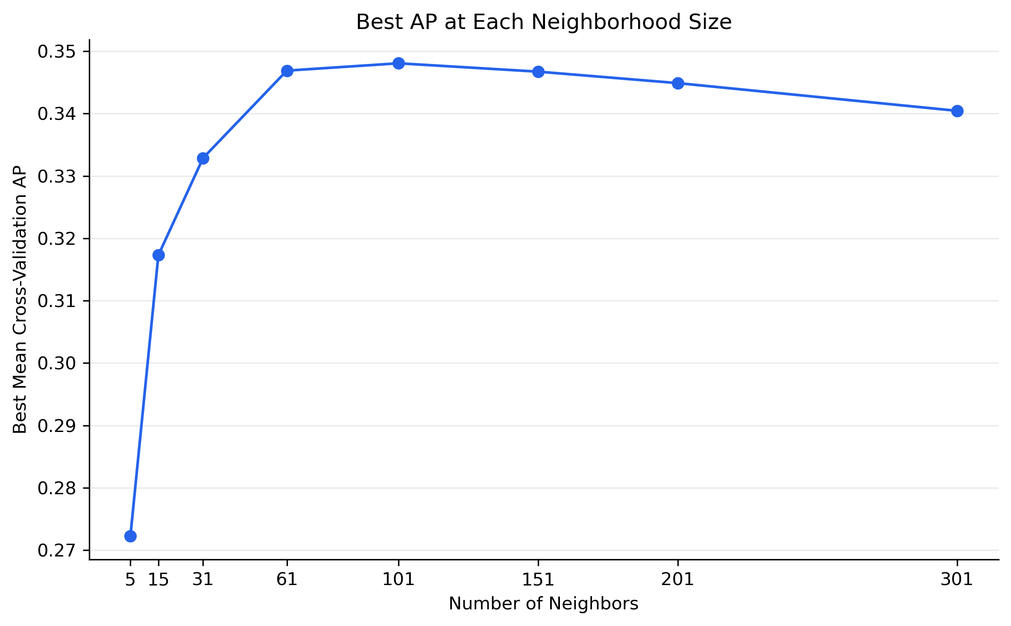
Figure 1. Highest mean CV AP among candidates at each k. Other settings may differ between points.
Performance is similar around k=61–151. The stated selection rule retains 101; the small differences are not claimed to be statistically significant.

4 Selecting a threshold using training data
AP measures how well purchasing sessions are ranked, whereas a threshold determines which sessions are classified as purchases. The AP-selected primary model predicts very few purchases at the default 0.5 boundary, so purchase-class F1 is used separately to choose a threshold. F1 balances precision and recall but does not maximize business profit.
The selected pipeline is refitted within the same five folds to generate out-of-fold (OOF) scores. Each observation is scored by a fold model fitted without that observation. Scores are pooled, and the threshold maximizing F1 is selected; exact ties are resolved in favor of the highest threshold. The primary threshold is 0.19365381 as displayed, with full precision retained for prediction.
Primary OOF rule | Precision | Recall | F1 | FP
Default | 0.7059 | 0.0079 | 0.0156 | 5
Selected threshold | 0.2803 | 0.6874 | 0.3982 | 2,694

The default rule uses score > 0.5, assigning an exact tie to class 0; the selected rule uses score ≥ threshold. Lowering the threshold increases identified purchases from 12 to 1049 but substantially increases false positives. AP and ROC-AUC are unchanged by the threshold; their pooled OOF values are 0.3444 and 0.7502.
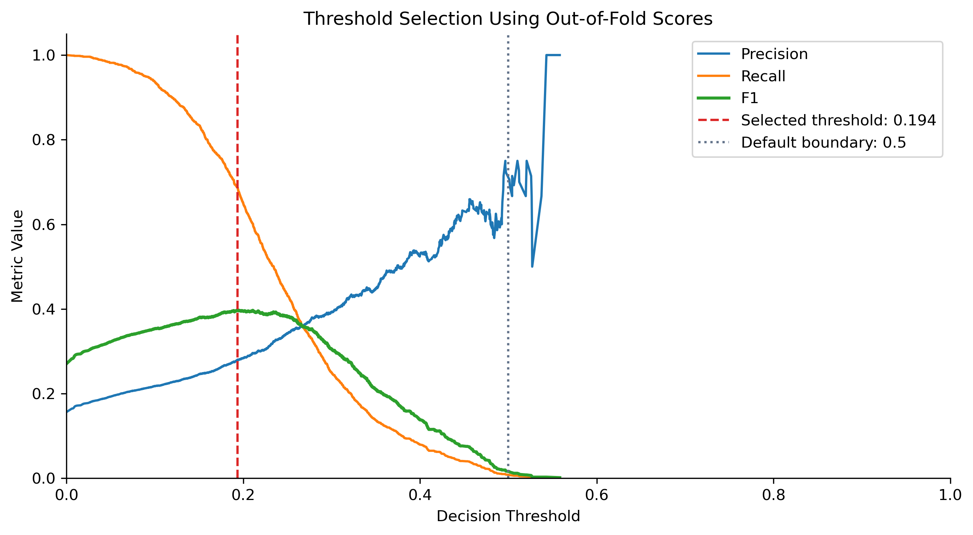
Figure 2. Primary-model OOF threshold selection. The red line marks the selected threshold; the green curve shows F1.
OOF results are development results: hyperparameter and threshold selection use the same training data and may introduce selection optimism. The held-out test set provides the final independent evaluation.

5 Final held-out test results
After fixing parameters and thresholds, both pipelines are refitted on the full training set and evaluated on 2441 test sessions. Of these, 382 involve a purchase; the all-negative test accuracy is 84.35%. Results retain both the default rule and the training-selected threshold.
Specification | Rule | Precision | Recall | F1 | Accuracy
Without PV | Default | 0.8571 | 0.0157 | 0.0308 | 0.8456
Without PV | Selected | 0.2933 | 0.6911 | 0.4119 | 0.6911
With PV | Default | 0.7186 | 0.5550 | 0.6263 | 0.8964
With PV | Selected | 0.6272 | 0.7356 | 0.6771 | 0.8902

PV denotes PageValues. Without PV is the primary model; with PV is the sensitivity model. Selected thresholds are approximately 0.1937 and 0.3586, respectively; both default boundaries are 0.5.
Model and rule | TP | FP | FN | TN
Without PV default | 6 | 1 | 376 | 2,058
Without PV selected | 264 | 636 | 118 | 1,423
With PV default | 212 | 83 | 170 | 1,976
With PV selected | 281 | 167 | 101 | 1,892

TP counts correctly identified purchases; FP counts non-purchases incorrectly flagged as purchases; FN counts missed purchases; TN counts correctly identified non-purchases.

Interpretation of the primary model
At the selected threshold, the primary model flags 900 sessions: 264 purchases and 636 non-purchases. It captures about 69% of actual purchases, but only about 29% of flagged sessions are purchases. The default rule achieves 84.56% accuracy yet identifies only six purchases, so accuracy alone does not establish that it is more useful for purchase identification.
Ranking metric | Primary | Sensitivity
Test AP | 0.3461 | 0.7176
Test ROC-AUC | 0.7660 | 0.9162

The primary model provides ranking information but produces many false positives. Practical usefulness depends on their cost and the value of identifying purchases. Its equal accuracy and recall values of 0.6911 are a coincidence of these counts.

6 PageValues sensitivity analysis
In training data, the purchase rate is 4.05% when PageValues is zero and 56.39% when it is positive, showing a strong association. The primary model excludes it because its construction and availability at prediction time are not sufficiently established. Strong association alone does not prove leakage.
The sensitivity model adds PageValues and is independently tuned using the same folds and 64 candidate configurations. The log1p option also transforms PageValues. The selected configuration uses k=31, distance weighting, Euclidean distance and Log1p + Standard, with mean CV AP of 0.7155 ± 0.0332 and mean ROC-AUC of 0.9126. Its threshold is independently selected using the same OOF F1 criterion, giving 0.35857186 as displayed.
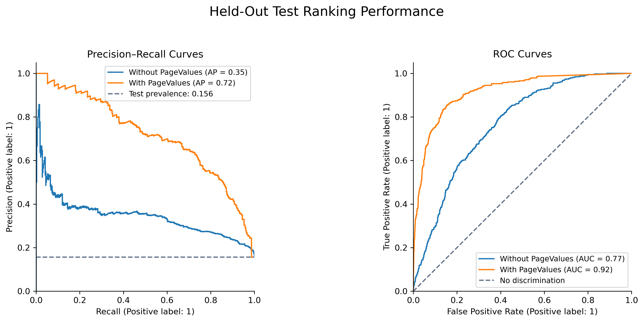
Figure 3. Test precision–recall and ROC curves. The dashed PR reference line is test purchase prevalence.
At their independently selected thresholds, the PageValues model identifies 17 additional purchases and produces 469 fewer false positives than the primary model. Test F1 rises from 0.4119 to 0.6771. Because the pipelines are independently tuned, the comparison concerns two optimized specifications, not an isolated feature addition with all other settings held fixed.
Specification | OOF AP | Test AP | OOF ROC-AUC | Test ROC-AUC
Without PV | 0.3444 | 0.3461 | 0.7502 | 0.7660
With PV | 0.7140 | 0.7176 | 0.9127 | 0.9162

OOF and test ranking results are similar, with no marked deterioration on this held-out split. This does not establish performance in future periods, on other websites or in different populations. Pooled OOF metrics and fold-average metrics are computed differently and need not be identical.

7 Limitations and conclusion
This experiment uses a conventional KNN workflow, emphasizing separation of model development from testing and transparent reporting of classification trade-offs. Parameters and thresholds are selected using the same training data, so development scores may be optimistic. Final results come from one fixed test set; confidence intervals and nested cross-validation were not implemented.
Thresholds optimize F1 rather than profit. Intervention costs and benefits were not specified, and KNN scores were not probability-calibrated. Correlated predictors may affect distance calculations redundantly, and results depend on encoding, scaling and distance choices. Feature reduction, dimensionality reduction, resampling and cost-sensitive experiments were not performed.
Session-level summary features may not all be available during an ongoing visit. Excluding PageValues does not automatically establish that the remaining features support early prediction. EDA describes associations, not causal effects or KNN feature importance.
In conclusion, KNN without PageValues provides purchase-ranking information. Its training-selected threshold yields recall of 0.6911 but precision of only 0.2933. The PageValues specification performs substantially better and remains separately reported as a sensitivity analysis. Parameters and thresholds were fixed before test evaluation; the reported test results are not used for further tuning.

8 Group integration and traceability
The group’s primary comparison should use the KNN specification without PageValues at its selected threshold, retaining the default rule as a reference. Comparisons across models should state whether the partitions, feature scope, positive class and threshold-selection procedures match. Comparing KNN with PageValues against other algorithms without it does not isolate algorithm performance.
Purpose | Supporting file
Code and saved outputs | KNN.ipynb
Test metrics and counts | results/knn_final_test_results.csv
Individual test scores | results/knn_final_test_predictions.csv
Shared CV assignments | results/cv_fold_assignments_seed6805.csv
Confusion matrices | figures/12_test_confusion_matrices.png

The recorded implementation uses scikit-learn 1.5.1 and cross-validation seed 6805. Reusing fold assignments also requires the same training-row order. Figures and tables report the completed experiments; no additional experiment is introduced here.
Project sources: the methods and discussion in KNN modelling.docx, and the code and saved outputs in KNN.ipynb. External literature citations and reference formatting should be integrated consistently in the final group report.

